Questions and Exercises to work out and turn in:

Grading Guidelines:

A right answer will get full credit when:

1. It is right (worth 25%)
2. It is right **AND** neatly presented making it easy and pleasant to read. (worth an **extra** 15%)
3. There is an **obvious and clear link[1]** between 1) the information provided in the exercise and in class and 2) the final answer. A clear link is built by properly writing, justifying, and documenting an answer (worth an **extra** 60%).
4. Calculation mistakes will be minimally penalized (2 to 5% of full credit) while errors on units will be more heavily penalized.

**Late Submission** : as specified in the syllabus. Days counting starts one minute after the deadline.

**Check Your Submission:**  after submitting, download your submission to check whether it is the right version and it is complete.

You are welcome/encouraged to discuss exercises with other students or the instructor. But, ultimately, **personal** writing is expected.

* USE THIS FILE AS THE STARTING DOCUMENT YOU WILL TURN IN. **KEEP IN THE QUESTIONS** AND INSERT YOUR ANSWERS.
* IF USING HAND WRITING (STRONGLY DISCOURAGED), REWRITE THE QUESTIONS.
* FAILING TO FOLLOW TURN IN DIRECTIONS /GUIDELINES WILL COST A 30% PENALTY.

Objectives of this assignment:

* to explore the relationship between switches processing time and propagation time

What you need to do:

Answer the questions and/or solve the exercises described below.

Exercise 1 (100 points)

*This exercise explores of the impact of the switching time (time spent on routers, switches or other intermediary networking devices) and the propagation time (distance).*

*A factor in the delay of a store-and-forward packet-switching system is how long it takes to store and forward a packet through a switch (router (L3 switch) or L2 switch). The objective of this exercise is to investigate the impact of the switch time on the overall delivery delay of a packet. The switch time is about 8 se per device: we assume (oversimplification) that each device adds this switching time to the packet delay in order to process (routing...) the packet. Consider a packet P sent from Auburn University (AU) to McGill University (about 2,250 kms from Auburn) over a copper line. Assume the propagation speed in copper to be 2/3 the speed of light.*

For the following questions, you will required to provide a screenshot. When asked, the screenshot should look like this template screenshot (we should see the username, the **tux** machine used, the date, the commands typed, and the results). **Failing to provide a screenshot meeting the requirements for any of the questions will result in a 50 points penalty**.:

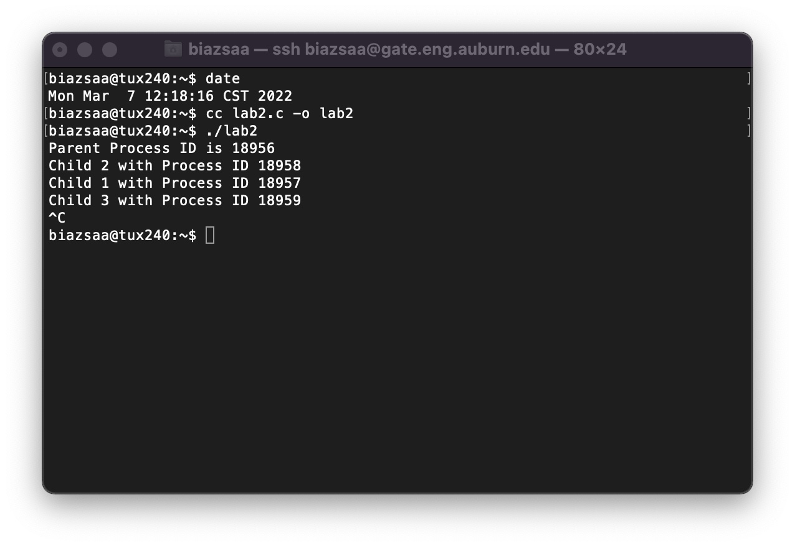

1. (32 points) What is the propagation time from the packet P to reach the destination? Ping *www.mcgill.ca.* Provide a screenshot of your ping collecting at least 20 ping packets. Report here the minimum, average, and maximum round trip time provided by Ping. Recall that the one way transit can be estimated as half the round trip time. Check/discuss whether your calculations (to determine the one way propagation time from source to destination) match the ping measurements. If the calculations do not match the ping measurement, propose possible explanations.

Round Trip Time (min/avg/max) = 42.786/42.910/43.027 ms

(One Way Transit Time) = 21.393/21.455/21.514 ms

In order to find the propagation time, we found the distance between Auburn, AL and Montreal, CA, which was 1383 miles. The formula for the speed is to multiply 2/3 by the speed of light.

Speed of light is approximately 3 * 10^8.

1383 miles = 2226000 meters

Therefore, the ending formula for propagation time is (2226000)(2.0 * 10^8 meter per second)

ANS: Propagation time = 11.13ms

As the results show, the one way transit time and the propagation time are not equal to each other.

* 21.455 ms != 11.13 ms

So possible reasons for the measurements not equaling are the transmission medium could have travelled over some wireless frequency, as well as the possible network traffic not being optimal.

1. (16 points) Provide the approximate number of switches (routers) between a computer at Auburn University and a computer at the destination. Provide the answer and do not forget to write how you found the answer. (You can use the command traceroute on Unix machines or tracert on Windows: let us know if you encounter difficulties.). Note that these commands do not reveal L2-switches. Provide a screenshot.

Using the traceroute command, due to the tracert not working, we attained 14 responses which means that there are 14 switches.

1. (20 points) Assuming that there are about 16 switches between AU and the destination, what is the ratio of the total switch time to the propagation time? Is the switching time a major component in the total delivery time? Discuss.

The ratio of the total switch time to the propagation time is calculated to be 128 mu, which can be shown as microseconds. We found the total switch time by multiplying the number of switches by the switch time that is provided.

16 switches * 8 mu = 128 mu.

Now we convert the propagation time to microseconds to match the total switch time.

11.13 milliseconds = 11130 microseconds.

Now for the ratio.

128 mu : 1130 mu = 0.01150 microseconds (mu)

1. (32 points) How many switches should there be between AU and the destination such that the switch time is equal to the propagation time? Discuss the impact of propagation time and the processing/switching times on the intermediary nodes. Which parameter impacts more delay on networks, propagation time or switching time?

In order to find the number of switches between AU and the destination to equate the switch time and the propagation time, we need to use the formula from part c.

(some #) switches * 8 mu = total switch time

Substitution of the total switch time with the propagation time.

(some #) switches * 8 mu = 11130 mu

Divide both sides by 8 mu to find the number of switches

11130 mu/ 8 mu = 1391.3 switches or approximately 1391/ 1392 switches

The parameter that impacts the delay would consist of additional sessions running at the same time, the packets being sent and received could slow the process even further. As we went through this assignment, we learned that propagation has relations with the packets travelling the medium o reach the destination.

**What you need to turn in**:

* Electronic copy of this file (including your answers) (standalone). Submit the file as a Microsoft Word or PDF file.
* Recall that answers must be well written, documented, justified, and presented to get full credit.
* How this assignment will be graded:
* A right answer will get full credit when:
* It is right (worth 25%)
* It is right AND neatly presented making it easy and pleasant to read. (worth 15%)
* There is an obvious and clear link between 1) the information provided in the exercise and in class and 2) the final answer. A clear link is built by properly writing, justifying, and documenting an answer (worth 60%).
* Calculation mistakes will be minimally penalized (2 to 5% of full credit) while errors on units will be more heavily penalized.
* You are welcome/encouraged to discuss exercises with other students or the instructor. But, ultimately, personal writing is expected.

**Appendix**: Grading: What is an OBVIOUS and CLEAR LINK?

Here is an example to explain what an **obvious and clear link** is and how we grade your work.

Consider the following problem:

"(100 points) John travels from Auburn to Atlanta in his car at a speed of 60 mph. Leaving at 8am, at what time will John reach Atlanta".

Here are the answers of three students and their scores:

* **Student 1** answers: "9:48am". Student 1 will get 25 points.
* **Student 2**answers : "John will reach Atlanta at 9:48am". Student 2 will get 25+15 = 40 points
* **Student 3** answers: "The time t to travel a distance d at speed v is equal to d/v = d/60mph. The problem does not provide the distance d from Auburn to Atlanta. Based on GoogleMaps, the distance from Auburn to Atlanta is approximately 108 miles (**document is attached HERE near the justification**).

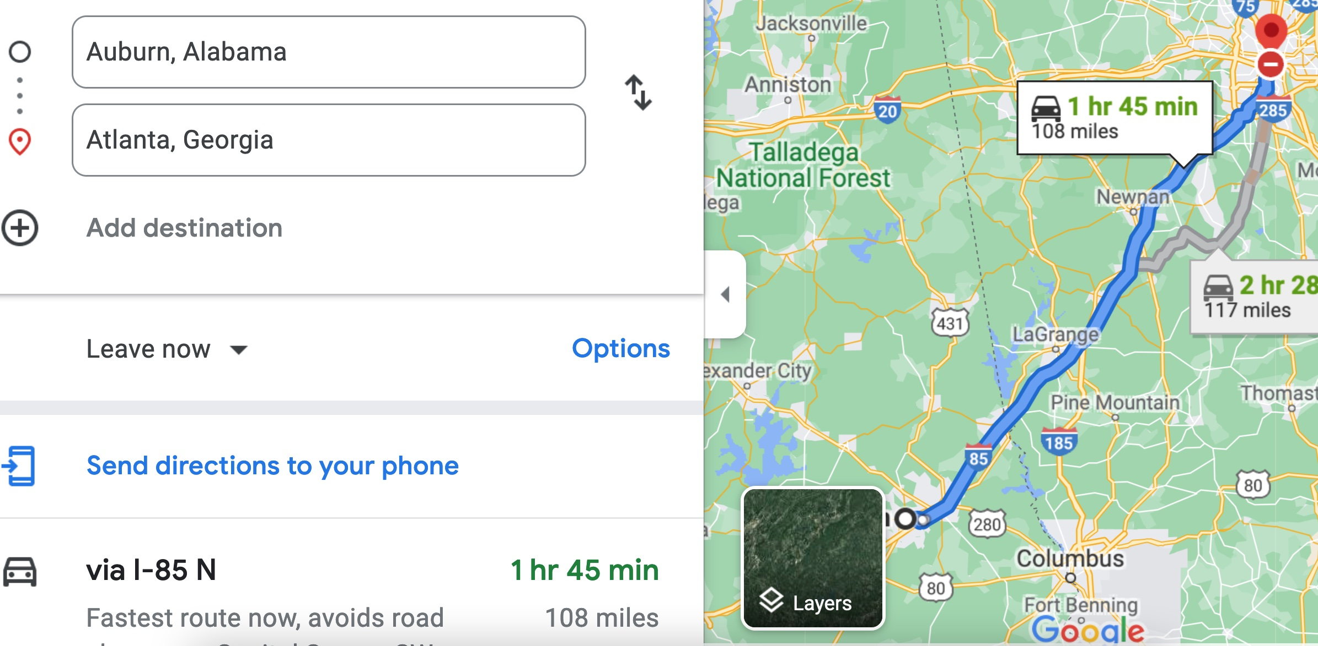

Therefore, the time t = 108 miles/60mph * 60 minutes/hour= 108 minutes. Since John left at 8am, he will then reach Atlanta at 8am + 108 minutes = 8 am + 60 minutes + 48 minutes = 9:48".

**Student 3** will get 25 + 15 + 60 = 100 points

Do you see the **direct** **link** going from the data provided in the question to the final answer, using general knowledge/formula and documents?.... Can you now solve the following problem and get 100 points?

"(100 points) Alice travels from Auburn to Atlanta in her car at a speed of 60 mph. Leaving at 8am, at what time will Alice reach Atlanta assuming that she had a flat tire that delayed her 30 minutes".

1. See **Appendix** about what an obvious and clear link is.